**Deadline Team Process**

Admission system

Contents

**Revision history** 2

**List of table** 2

**1.** **Introduction** 2

• **Purpose** 2

• **Goal** 2

**1.** **Architecture process** 3

**2.** **Role and responsibilities** 4

• Responsibilities 4

• Role 5

# **Revision history**

|  |  |  |  |
| --- | --- | --- | --- |
| **Version** | **Updated Date** | **Author** | **Description** |
| 1.0 | 11/19/2013 | Ta Ngoc Thien Phu | Create document |

# **List of table**

Table 1 Process Description 4

Table 2 Responsibilities 5

Table 3 Role 5

# **Introduction**

## **Purpose**

* This purpose of this document is show general view about architecture process and guide members how to design architecture in Admission system project

## **Goal**

* All members can overview about architecture process
* Know task that they have to design in architecture phase

# **Architecture process**

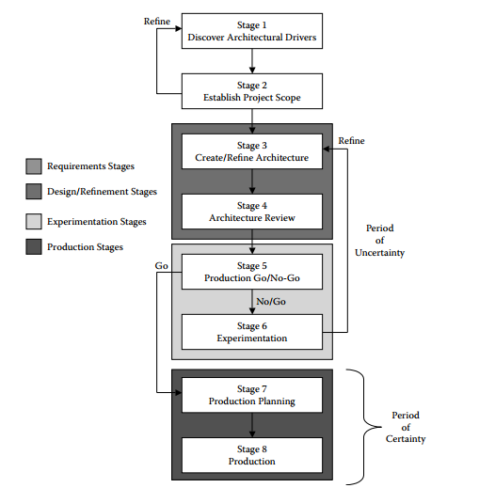

*Architecture process*

|  |  |  |
| --- | --- | --- |
| **No** | **Phase** | **Description** |
| 1 | Discover architecture drivers | Get data that required from customer, data have to high level  This phase, requirement engineer only collect data from customer, not analyze |
| 2 | Establish project scope | Use data that collect from phase 1, engineer start analyze and define project scope  Priority for data that collect from customer |
| 3 | Create / Refine architecture | Create design architecture drivers, if architecture driver need refine after completed experimentation from phase, re-design/refine architecture drivers |
| 4 | Architecture review | Design Team will review architecture drivers |
| 5 | Production Go/ No-Go | In stage 5 the team has to decide whether the architecture design needs further refinement or if they should proceed into production planning. |
| 6 | Experimentation | The purpose of the experiments is to address specific issues that arose during the evaluation; thus, the architecture guides the team in discovering and mitigating risk. Once the experiments are executed, the team returns to stage 3 |
| 7 | Product planning | The primary purpose of stage 7 is for the architecture design team to use the architecture to plan the subsequent design and implementation of the system or product. ACDM does not prescribe  specific methods, detailed design, or development process frameworks, but ACDM does provide guidance and techniques for planning the postarchitecture design activities based on the design |
| 8 | Production | In stage 8, the elements of the system are produced, tested, and integrated into a system or product. |

*Table 1 Process Description*

# **Role and responsibilities**

## Responsibilities

|  |  |  |
| --- | --- | --- |
| **No** | **Roles** | **Responsibilities** |
| 1 | Managing engineer: | The managing engineer is responsible for coordinating the overall system design and development effort. Although they are responsible for the success (or failure) of the design team, they must also be able to listen to other members of the design team |
| 2 | Support engineer | The support engineer is responsible for setting up and maintaining the design team’s support tools and environments, such as development environments and tools, configuration management tools, test environments and testing tools |
| 3 | Chief architect | The chief architect is responsible for overall system design. He or she will work with all of the other members of the design team to coordinate the system design, beginning with gathering the architectural drivers, designing the architecture, reviewing it, refining it, and documenting it until production and deployment—preferably throughout the system or product life cycle |
| 4 | Requirements engineer | The requirements engineer leads the effort to gather and document the architectural drivers. He or she will also help to manage the change and evolution of the architectural drivers—preferably throughout the system or product life cycle |
| 5 | Chief scientist | The chief scientist is the project technologist and is primarily responsible for coordinating the planning, tracking, and documentation of experiments that are used to refine the architecture design |
| 6 | Quality process engineer | The quality process engineer ensures that ACDM and other defined processes are followed as prescribed to ascertain project quality goals are met. The quality process engineer is responsible for coordinating architecture design reviews as well as product test development, planning, and execution |
| 7 | Production engineers | These are team members whose focus is on detailed design, implementation of the architectural elements, and integration of the elements to compose the system |

*Table 2 Responsibilities*

## Role

|  |  |  |
| --- | --- | --- |
| **No** | **Roles** | **Members applied** |
| 1 | Managing engineer: | Chau Le |
| 2 | Support engineer | Huy Ngo |
| 3 | Chief architect | Phu Ta |
| 4 | Requirements engineer | Khang Huynh |
| 5 | Chief scientist | Dao Khau |
| 6 | Quality process engineer | Huy Nguyen |
| 7 | Production engineers | All team |

*Table 3 Role*